ACCS LTD Placement report

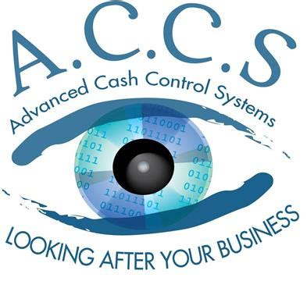

Prepared For:

Patricia Jennings

Created By:

Sean Carlin

*North West Regional College*

Table of Contents

Introduction 4

The Organisation 7

The Job 12

Evaluation 17

Conclusion 19

References 20

Appendices 21

Appendix 1 21

Appendix 2 22

Appendix 3 23

Appendix 4 24

Weekly Logs 25

Week 1 25

Week 2 26

Week 3 27

Week 4 29

Week 5 32

Week 6 33

Week 7 34

Week 8 36

Week 9 38

Week 10 39

Weekly Log References 40

Presentation 41

Slide 1 41

Slide 2 42

Slide 3 43

Slide 4 44

Slide 5 45

Slide 6 45

Slide 7 46

Slide 8 47

Slide 9 48

Slide 10 49

Slide 11 50

Slide 12 51

Slide 13 51

Slide 14 52

Presentation References 52

# Introduction

At first, I struggled with my course however, *“failure enables you to learn, grow and perfect your methods” [*Branson (2014)]. I'm about to finish my final year as foundation degree student learning Software Development at North West Regional College, it has been a challenge and the last couple of months have been the most challenging. All that is left to complete is my last unit, Work-Based Learning. Which introduces us to the reality of working within a software company and provides the opportunity to bring together the knowledge and skills acquired in every other unit and apply it now in a real-world setting. We are introduced to this by a 3-month placement, with my placement being the final stage to complete my course I was very eager to get started.

To acquire placement our work-based learning officer gave us the task of finding a company first, which I think was a great way of teaching us how the real-world works, this led to creating a **LinkedIn** account (Figure 1) to expand my field and chances. I obtained a successful placement via countless hours of research, numerous phone calls and countless emails to a vast majority of software companies around Northern Ireland, Southern Ireland, and even a couple in Germany.

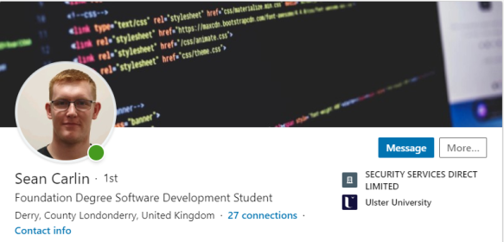

**Figure 1**

I got the opportunity to attend a couple of interviews, but those companies could only take me on for a year’s placement, although it did help boost my interview experience as I carried out multiple mock interviews to prepare. Through my personal professional development course at the college, I wanted to increase my chances of finding placement for my work-based learning unit, I attended a LinkedIn workshop and even a CV building workshop, from this I learned how to properly present myself to potential employers and how do make my CV stand out amongst others, giving me extra confidence. Unfortunately, I wasn’t very successful finding placement until a couple of days near the deadline. I eventually got accepted into working with ***Advanced Cash Control Systems LTD (ACCS)***. As soon as I found out I got placement I could only think, *“Good things come to those who wait” [* Lady Mary Montgomerie Currie (2020)*].* Here are only some of the major companies I applied for.



The project I was tasked with was more of a business problem. I found this a great opportunity for me to dive straight into developing with a new language, to build a solution, and find out how issues like this are dealt with in the workplace. The problem consisted of out of date ‘*Demonstration Data’*, ACCS supply and manage Vectron Till Systems that are programmed to your business needs, to show this they run demonstration events of their systems. It's unprofessional to be running a system having out of date data as this can put off potential clients and show lack of maintenance within the company, however, *“Development is Maintenance” [ Brian Marick (2020)].* The solution would be to implement an automated function of ***fictitious sales data***that will generate financial reports *automatically* without needing human input. To work it must be tested, as “*Automation applied to an inefficient operation will magnify the inefficiency” [* Bill Gates (2019)*].* This solution has many benefits, as it can be done in a matter of seconds, reducing wasted time and can be used within any business till-system, basically a plugin. To explain this in a more presentable manner, refer to the solution diagram below (Figure 2)

To create sales data, sales must be made, and they all must be random, you can see an example of one of the methods created in Appendix 4. So, *Mary* is going to be automated, random *‘Operators’(*users) will be logged in to the system and make random sales with random products (PLUs) and once that is completed, the reports are then generated and saved, then synced with Titan. Titan is the Business Intelligence Suite development ACCS. The main function of Titan is to provide up-to-date data for making the right business decision.

Sale 6

Sale 3

Sale 2

Generate saved Reports

Sale Data

Mary = Humanised Input

I come in here

**Step Process:**

1. User
2. Time
3. PLU
4. Pay

1

2

3

Z-Reports

Sales Data

Synced to Titan

PLU

User

Payment

Timer

**Sales**

**Titan = Business Intelligence System**

**Figure 2**

My placement is located quite far from the college, just outside Antrim in a small but relaxed office which was established in 2007 and has been very successful since. Within this office there is myself, another Software Developer who of which is also my mentor, an accountant, and the CEO of ACCS. I work at my desk with a dual monitor setup that’s hooked up to my laptop. Reasoning for using my laptop is because it helps with accessibility, I can take my laptop home and continue exactly where I left off, including working from home in general. When I arrived at the office on my first day, I was given the latest software required to work with Vectron Till Systems, including a *‘Security Key’* which is encrypted to give access to those authorized to work on Vectron systems.

Throughout this report you are going to see how I’ve developed over the weeks learning a new programming language, one step at a time as “*one step is better than no steps”[Rebecca Brockway],* and working within a new area of computing systems based on the Cloud. As well as the company I am currently working for.

# The Organisation

Businesses use mission statements to focus on their path and go towards the right crowd they’re aiming for, because “*without a mission statement, you may get to the top of the ladder and then realize it was leaning against the wrong building!”.* Advanced Cash Control Systems Ltd, or ACCS for short, is an advanced retail systems company(hence the company name) that supplies top of the range Vectron till systems(**Figure 3**) that are altered and programmed to your needs, to retailing and hospitality companies all over Northern and Southern Ireland, as well as Great Britain. Vectron is a German company who design, manufacture, and supply the till system to their dealers around the globe. These EPOS Systems are the most beneficial systems to increase business profits whilst controlling stock and financial accounting, ensuring nothing is missed and everything is accounted for.

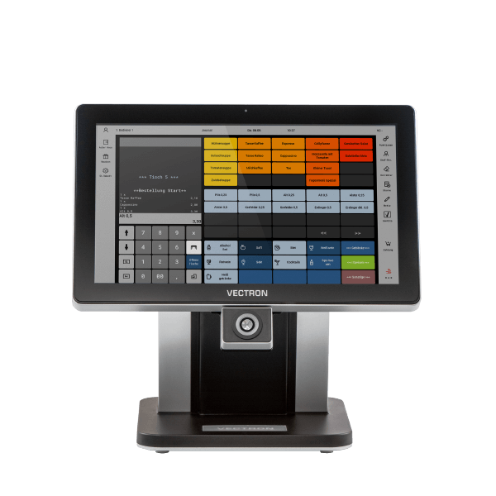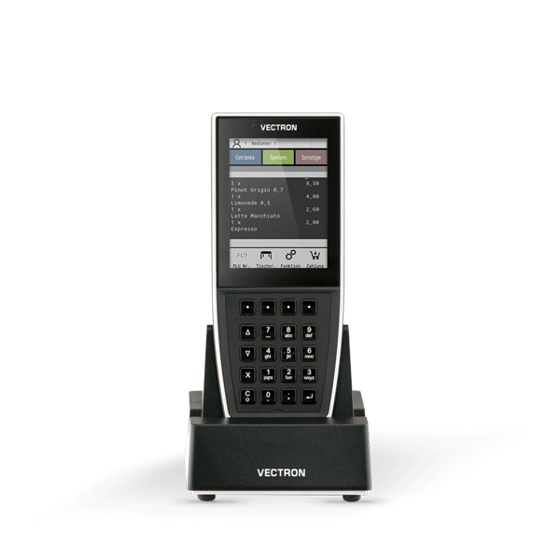

**POS MobilePro III**

**POS Touch 15 II Wide**

**POS Touch 15 II**

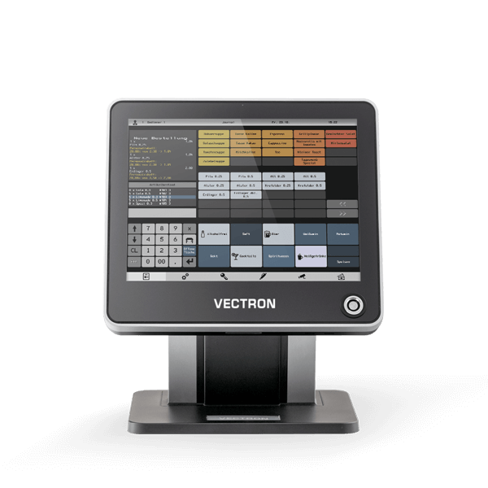

**Figure 3**



When a potential new client needs a till system, they would have a meeting with the ACCS CEO, Roger McDermott, where they would discuss the clients' business needs, which could be a small bar, large restaurant, a shop, or anything else involving products and cash flow. Roger would handle support and sales for both Titan and the Vectron EPoS systems. However, these systems aren’t just supplied and fitted, these systems are programmed to your needs via Support department by the head developer, Theo Huenestein(**Figure 4**).This could be a ‘table selection map’ for restaurants with specific eating areas or a specific report, all of this is completely custom to the client's needs,  *“as good design is thorough, down to the last detail”[Dieter Rams],* maximizing the benefits of having an EPOS system.ACCS also supplies the ‘mobile’ versions of the tills (**Figure 3 – MobilePro**) which is a handheld device where the user can place table orders and have them processed whilst on the go, helping with accessibility. ACCS offer 24/7 support with their systems as they also manage your Vectron systems with a cloud-based business intelligence system known as ‘Titan’, a back-office software program where the client can view every detail regarding their business performance, profits, stock levels and much more.

**CEO**

**Roger McDermott**

**ACCOUNTING**

**SUPPORT**

**SALES**

**Head of Software Development**

**Theo Huenestein**

**Accountant**

**O. Mallan**

**Figure 4**

**Technical Software Sales**

**Titan Business Intelligence**

**Advanced Cash Control Systems Ltd**

**Roger McDermott**

**Technical EPoS Sales**

**Titan Dealers**

* **Absolute Retail Control, Dublin, R.O.I**
* **Insignia Business Solutions, Wales**
* **Cornish EpoS Systems, Cornwall, England**
* **Vectron South Africa, South Africa**

**Technical Titan Software Support**

**Technical EPoS Hardware Support**

**Technical EPoS Software Support**

**Roger McDermott**

**Vectron Systems AG Software Support Department, Germany**

**Vectron Systems AG Hardware Support Department, Germany**

**CUSTOMER**

**Programmer**

**Sean Carlin**

**Organisation Structure**

As you can see from the organisation structure, Advanced Cash Control Systems have very little staff, however each staff member has multiple roles. With Roger McDermott being not only the CEO of ACCS, but the creator of Titan Business Intelligence and sales for the Titan solution and Vectron Systems. Roger is also involved in the supporting department, where he provides support for both hardware and software enquiries for Titan and Vectron. The head of the software development department, Theo Huenestein manages anything relating to the plugins for Vectron systems as well as Titan technology. Theo is also my mentor, who has walked me through my tasks for this placement. Finally, O.Mallan is the accountant for ACCS, where he would handle anything financially related like invoices, payments and wages for the staff.

Advanced Cash Control Systems have a variety of top of the range software packages **(Figure 5)** to ensure the business runs efficiently and smoothly. These programs have multiple roles, from customer assistance and client management, to simply creating an invoice or tutorial document via Microsoft Word. With Visual Studio Code being one of the key programs needed so everything related to Vectron and Titan can be programmed and coded to the required standards. Vectron based software is mainly used to manage the Vectron systems and plugins, TeamViewer and ConnectWise are used for communication purposes via remote connection with clients. Pluralsight is an educational based website that provide users with tutorials for almost every language showing the basics and advanced of those languages. Without these programs ACCS would not be capable of keeping up with client demand nor would they be able to manage their Vectron systems and packages.



**Figure 5**

**Vectron Commander**

**Vectron POS**



**Vectron TCP Log-Viewer**



**Visual Studio Code**



**Microsoft Azure**



**Microsoft Office 365**



Within Advanced Cash Control Systems there are basic policies in place, with the most important one being the **health and safety at work act regulations 1999**. Where the workplace must be safe for their employees to work in regarding working conditions and its overall environment. Another important act within ACCS, especially since they are a software company, is the **Data Protection Act 2018,** where all client personal data is used by businesses fairly and only what it’s needed for. This information is also kept safely and securely away from unauthorised viewers.

With the recent pandemic, it has made clients of ACCS realize they need to have an online ordering and delivery solution. Although businesses have been advised to have an online presence since the start of their contract, they are only realizing now due to the closure of their restaurants. This has made them rethink their business model when it comes to an online presence, as there's a lot of potential when you’re open to a wider audience. So, the team has refocused a lot of their energy towards this by using a combination of Vectron hardware software and in house developed online solutions to provide for these clients.

Advanced Cash Control Systems can supply their clients with the most technically advanced cash systems with advanced software also, for any needs required. As shown in **Figure 3** they are the most commonly used systems within the hospitality and retailing sector, however, that’s not all, they have peripherals that help with accessibility and customer guidance when it comes to displaying products and final prices (**Figure 6**). I have used these systems myself and can’t get over how technologically advanced they are, it makes running your financial area of your business easy and a lot less complicated. Another key factor with these Vectron systems is down to the ‘Magnetic Key-FOB’, which is a magnetic key that the user would carry with them. Once this makes a connection with the key pad(**Figure 7**), it logs the user programmed to that key-FOB into the till system. This makes it much quicker during busy hours and prevents users logging in to the wrong ID.

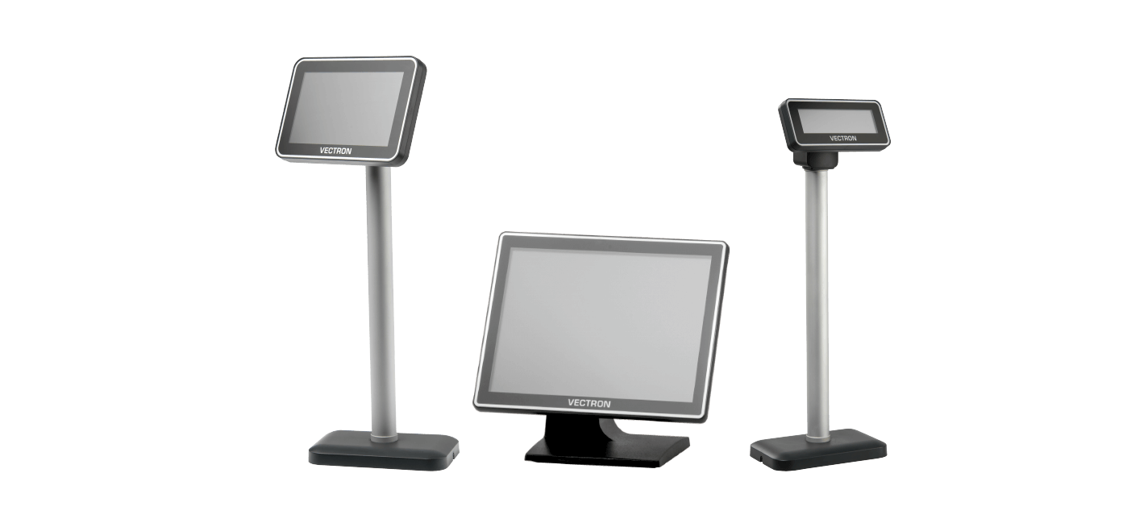

**Figure 6**

**Vectron C100**

**Vectron C75**

**Vectron C56**

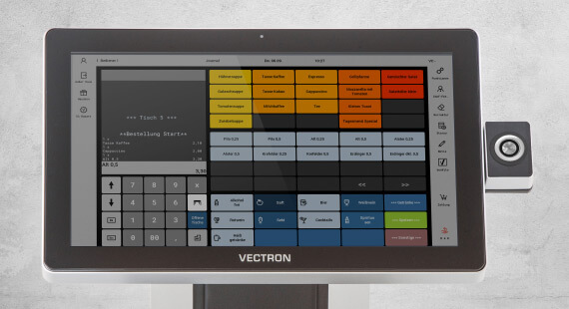

**Figure 7**

**Magnetic Keypad**

**POS Touch 15 II Wide**

During my placement I’ve gotten to work with not only the Vectron systems but with the Vectron software(**Figure 8**), where I have been working on a script to help generate demonstration data. Working with this software has given me a real insight to the world of software development within the industry and made me realise that this wasn’t a simple project from my college course, I’ve had to teach myself a new language within a timeframe to prepare myself to begin the project, which was difficult at first, however, *“I am still learning”[Michelangelo].* Working with ‘Vectron POS’ is the same as working with a physical Vectron till, except its virtual and on your computer(**Appendix 1**), this was very beneficial to me when I had to test the new pieces of code and run the new scripts. Further down the line I was then introduced to ‘Vectron TCP Log-Viewer’ which helped me test and view my script step by step more efficiently(**Appendix 2**). Vectron Commander allows me to connect to live tills and make alterations if needed, this could be as simply as updating a childrens food menu, or the prices of a drink and so on. This is also used for customer assist when needing to diagnose and error with a till.



**Figure 8**

**Vectron Commander**

**Vectron POS**



**Vectron TCP Log-Viewer**



**Visual Studio Code**

# The Job

Upon my first day working within Advanced Cash Control Systems, I was introduced to a manner of new software programs to prepare myself for the new language, Lua, that I was about to start learning the following week. The software I was introduced to was Vectron Commander, Vectron POS, Vectron TCP Logger down the line but most importantly Titan. Titan is a business intelligence system which is cloud based, making it accessible 24/7 to authorised users, Titan is the heart of clients’ business information as everything from their Vectron till systems are synced every night when out of business hours. This means that authorised users can view *live data* when needed, authorised users within that business have limited access where they can view specific data.

To start off my placement practically, I had to be taught by my mentor how to use the software programs by doing various procedures like Vectron Commander. Vectron Commander is used to take control of *live* till systems, or mobile systems for various functions, these functions would be updating the products on a menu like their prices or description, adding new product stock items or making specific changes in general. All of this co-operates with Titan and is done remotely from the main office of ACCS, another key function that Vectron Commander provides is the ease of accessibility to clients when they require assistance or when a technician needs to diagnose an error with a till system, because *“The role of genius is not to complicate the simple, but to simplify the complicated.”[Criss Jami, (2018)].* As mentioned before, Vectron POS is a virtual Vectron Till which helps the developers to test and import new scripts to make sure everything is running correctly. To develop scripts for these tills, we must use Lua, the Lua language is essential when working on scripts for the Vectron tills, as they are not compatible with any other language, it’s also a very simplistic language that’s efficient when writing ‘plugin like’ scripts for the Vectron tills. To create my solution, I must learn this language. After learning multiple languages during my Software Development course, I feel I can transfer those skills gained over to learning Lua, as Java and C# are like Lua but with more simplicity in terms of basic functions like IF statements and loops.

After being introduced to the environment I’m working within; I have been given the task to design and develop a solution to resolve the current business issue when it comes to seeking out new clients. When ACCS want to seek new clients, they must perform demonstrations of their Vectron till system in action as well as Titan. During these demonstrations, more data needs to be presented, as the current data it out of date as it hasn’t been used since the last demonstration, new data is needed per demonstration also. This can be resolved by updating the data ad hoc, however, generating data manually via human input is cumbersome and expensive in terms of time, that can be used elsewhere more valuable. I relate this method to *"The age of automation is going to be the age of "do it yourself" [Marshall McLuhan (2018)],* personally I disagree with this until it becomes too costly to be done by a staff member.

To resolve this solution, I have come up with a proposal which introduces an automated function of fictitious sales data into the Vectron Software where all the demonstration data required is generated within a quick timescale, everything within the data will be randomised therefore giving the client a proper insight to every possible outcome. Once this data is generated the Vectron tills do their usual routine by generating and updating financial reports, stock level reports and so on, all this data is then synced with Titan. As mentioned before this data can be viewed by clients whom are authorised.

I have decided to consider the ‘*Waterfall Method’* for the development of this new solution as its due within a timescale, this method is very beneficial as it allows the team to set deadlines for each stage of their project, helping to properly plan and stick to their schedule. My reasoning for the choice of this method is because it’s very efficient and helps achieve suitability when designing within a business, as *"Suitability is the quality that makes things durable*.” Billy Baldwin (2017). I mainly learned this during my Business Application Development course at the college and it prepared me to use this type of information in the real-world setting. Whilst working with a *live business* I decided amongst our group that the waterfall method and personally I think it worked out amazingly considering we got our work completed just before the deadline. Throughout this process I will be researching the requirements needed, followed by the design of the solution, the implementation of the script to the Vectron till systems and then to finish it off with verification and maintenance. After some research and a few meetings with my mentor, we came up with the following requirements:

1. Sales Data *needs* to be created fictitiously.
2. A Security Key Chip is required to access the Vectron Software.
3. This function must be automated.
4. Must be written in Lua language.
5. Must be completed in time for the client.

To develop a solution with these requirements, a lot of research and knowledge is required to have this completed within the given timescale. This led me to creating a project proposal to present to my mentor, Theo Huenestein, during this task I asked a lot of questions because *“If you want the answer – ask the question”. [Lorii Myers 2018].* I did a lot more research of the Lua language, working with Timers, IF statements and random number generators. When creating the project proposal, it seemed to be rather a simple task, saying as I also learned to make one during my Business Application Development Module working with a live business. Once my project proposal was created, I learned what steps I needed to take to make sure everything is developed on time.

I had to research a lot of the Vectron’s API (*Application Programming Interface – Appendix 3*) to consider what functions I would need, and which ones are best for efficiency in terms of memory use and what methods correspond to generate the sales data needed. After numerous meetings with my mentor, we discussed that we wanted everything to be completely random, this mean random PLUs, random quantities, random operators(users), all of which will be happening at random, simultaneously. Before I begin writing the new script, I need to acquire the security key, which is a physical USB that allows me to access Vectron Software *only* if I have that key present within my computer. You can see in **figure 9** the process of what happens with or without the key.



**Figure 9**

After taking an online course on the Lua language showing me the basics and how to use basic functions, I knew what to do, I began developing the first script with Lua, which was very similar to languages I used on my course like Java, so I found it simple until it came to complicated parts. As I was progressing with the script, I started to realise a lot of key techniques I learned from my course, mainly encapsulation and scopes. When using Vectron API, my code started to get very untidy, therefore I had to create a secondary class to contain all my methods, having this attitude towards my work proved to be experience from my programming module and helps to be very beneficial in code. Having my methods *encapsulated* in a separate class reduces the amount of memory used when the script is running, it also means I can *“Write once, run everywhere” [Sun Microsystems 2020].* In figure 10, you can see where I have declared what *‘xOperator’* is, and how it is used multiple times under the one name, reducing excessive code and memory used to compensate for that extra code if it were included. You can see where this method is created in the separate class at **Appendix 4**.



**Figure 10**

As mentioned above, encapsulation helps to reduce and hide complexity, however, the other technique known as *‘Scoping’* plays a big part in my Lua scripts, as I have a separate Lua script called *‘DemoDataGeneratorLibrary’*, where all methods are stored and can be used simultaneously when called, to call these methods, you simply type the script name, followed by the method required, for example, *DemoDataGeneratorLibrary.getRandomQTY OR DemoDataGeneratorLibrary.getRandomMedia.*

As it approached the deadline for my solution, it was time to start rigorously testing the script, this included testing every function was running as it should and co-operating with its calling points. At first, my technique of testing did not include a third party program or a ‘Debugger’ to go through each part of my script, I stuck with the simple message box technique, as you can see in **Figure 11,** I have placed multiple lines of message code to display a message box once the program reaches that point in the script. This is very similar to a ‘Breakpoint’, which is an in-built **debugging** function in most coding programs to diagnose faults within your code, A **Debugger** is used to go through your code line by line so you can pin point where the issue is, I also learned this during my Business Application Development Module, where it prepared me for working with a software company where I wouldn’t have a tutor to ask for help and would have to work independently.

**Figure 11**

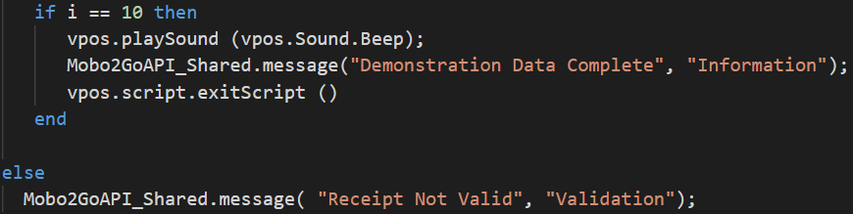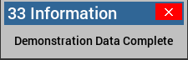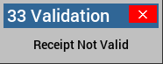

To ensure I had every step of my script ‘*logged’* for diagnosing purposes, I started to use the TCP Log Viewer. This is very similar to a Debugger, or the message box method as mentioned above, because if you want a specific part of your program to be ‘*logged’,* All you have to do it include a single line of code so the TCP Log viewer software can pick it up and display it on the window.

**Figure 12**

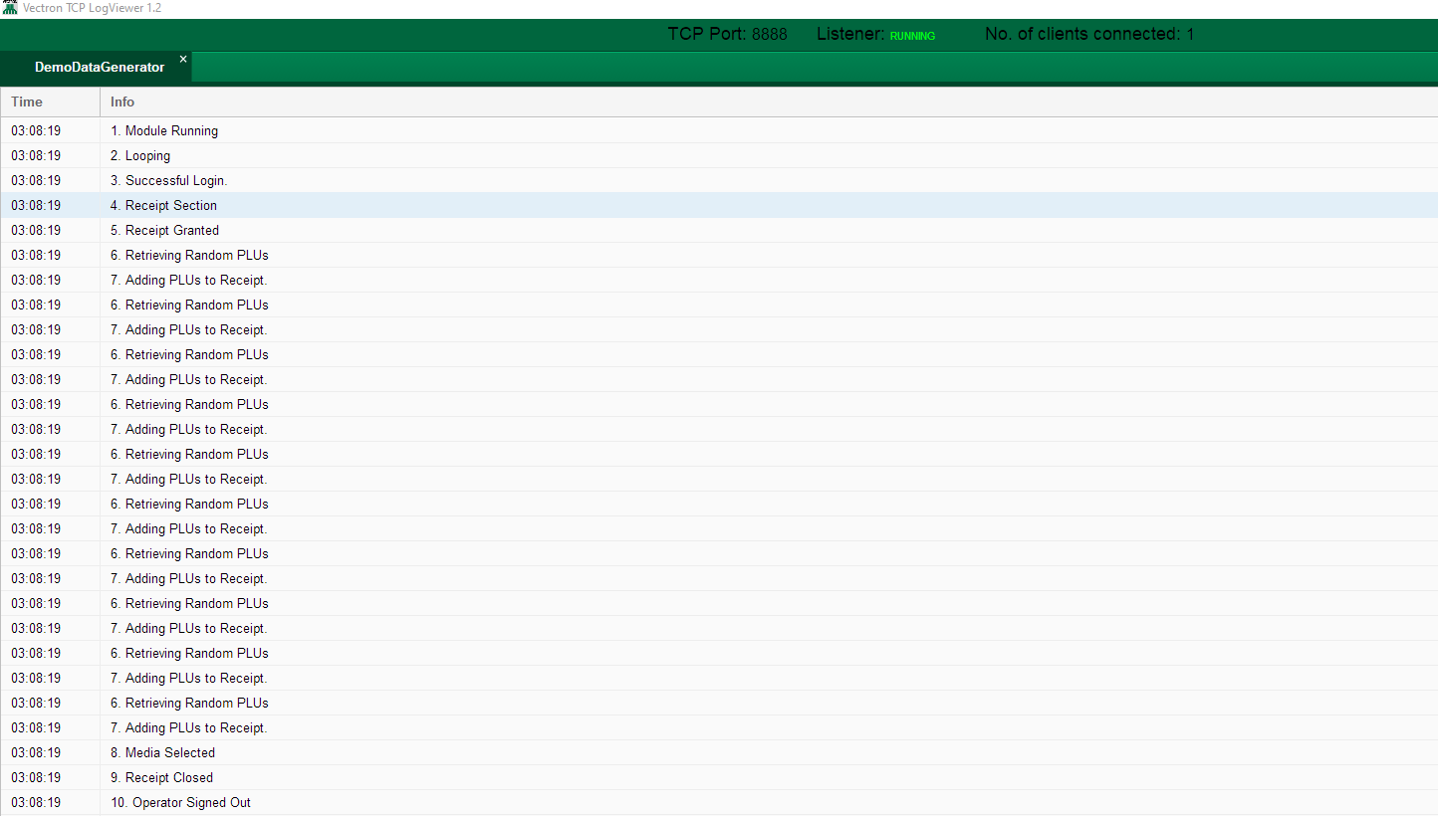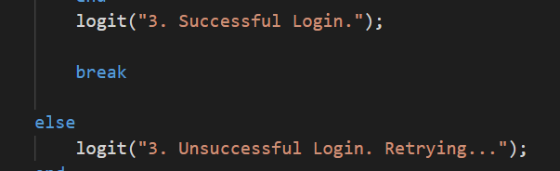

However, to tell the TCP Log viewer that I want an area of code to be saved into the log, the Vectron software must be connected to my computer to communicate, this is done via the methods in **Figure 13**. This method is called a ***Socket.*** A socket is a key commination method between two computers, mainly for network-based software programs. In this case, it is between the Vectron virtual till and the TCP Log viewer (**Appendix 2**). During my placement this was one of the most beneficial techniques, it may be a little thing to some however the *“Little Things, have Big Returns" [Daryl Travis (2020)] ,* to know how two software programs communicate to one-another will benefit me in the future when needing to diagnose scripts or document the programs procedure in general.

**Figure 13**

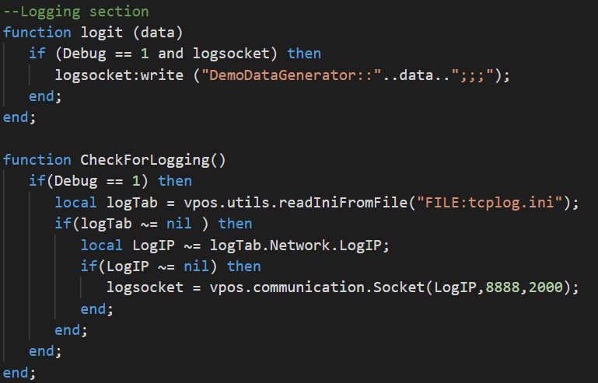

This registers the log point, wherever this is placed, it will be registered in the Log Viewer (See **figure 12**)

This method is how the Vectron Till connects to the Logviewer once it is running, it reads in the IP Address from the **TCPLOG.INI** file and establishes the connection.

# Evaluation

Working with Advanced Cash Control Systems rewarded me with experience like no other, working within this relaxed and welcoming environment has been very encouraging to continue my studies with software development. I experienced how things are done within a work environment, like maintaining your workspace, communicating with other colleagues and getting tasks done on time. Before beginning placement, I was paranoid about going into a new workplace and working with new people but most importantly, working with software on a whole new level with no experience outside of my course. After settling in, I was more confident to learn the Lua language, which is something I personally think I’ve developed greatly as I always struggled with languages, work placement has given me the confidence to go and learn new languages under my own initiative, as *“A lot of people never use their initiative because no-one told them to.”* [Banksy (2017)].

One of the things I learned whilst on placement was how the workplace functions, typically I’m used to working within a classroom where I don’t have to wear a uniform or stick to the one task. However, during placement I had to focus on my given task, ensuring it would be completed by its given deadline, this is something I had confidence in doing due to having multiple assignments also having a deadline. This eventually made me realise that I’m no longer in a classroom and that I’m independently in the real world of work where I need to stay on top of my targets. It also gave me a better understanding of communication with other people, especially when working on a group project. During my course I worked in a group project of 3 with a live business so I already had some experience within that area, although I personally think going through a group project during placement has developed my group co-operation further. Within Advanced Cash Control systems, I was introduced to not only Vectron software, but the physical Vectron till systems, and seeing how the ending results of a developers work turns out gave me more encouragement towards my project.

My overall learning of this work experience has taught me a new programming language, Lua, where I used this to write and develop a ‘plugin’ for a Vectron till, that randomly generates demonstration data that is required for client introduction meetings. During the development of this plugin I learned how to remotely connect a program to my code via a ‘Socket’, which was completely new to me at the time and never been taught on my course, it turns out this is a key method for computer programs to communicate and exchange data. I also learned how to program the Vectron till GUI (Graphical User Interface) so my new plugin can be triggered by a user. However, for the plugin to work I had to import two script files so the till system knew that the plugin was there, again this was completely new to me and will benefit my work ethic in future placements having this knowledge.

During my placement an unfortunate pandemic took place, therefore most of my work was done remotely from home and I kept communication with my colleagues via Skype, WhatsApp, Microsoft Teams and even TeamViewer (**Figure 14**). TeamViewer is a remote connection software which allows users, my mentor in this case, to access my computer and give me a thorough walkthrough of any issues I encountered. However, I wasn’t walked through everything, this was the disciplinary side of working alongside my mentor, I improved character by taking things into my own hands and teaching myself, experiencing the reality of working within a company where you must work independently. From this I also gained more confidence working independently from home, at first working from home was a struggle, however I kept in mind you *"Don't work from bed. You want your bed to be a place of peace and calm, not work stress." Liz Grossman Kitoyi(2017).* This made my rough days easier and ensured I will progress further the next.

**Figure 14**



The solution I’ve developed during this placement is now complete, it has been thoroughly tested by my mentor, Theo Huenestein and by my boss, Roger McDermott on a Vectron Till system in their main office. I also tested this solution during the development process, I learned how to test programs from my visual programming module at the college, however I required feedback from my colleagues to ensure it was in proper working order. This solution I have created is currently being used in *live businesses* to present demonstration data, and that personally is encouraging for myself to endeavour my future projects with software organisations.

Overall my work experience with ACCS was very beneficial to me, it has enhanced my confidence of not only working with a software company, but by working independently and most importantly within a team, because *"Alone we can do so little; together we can do so much."[ Helen Keller (2017)].* I am now fully capable of approaching a software company knowingly capable of working with various languages, cloud-based software and systems, and having great communication skills with other colleagues within the software sector. My chances of a future career elsewhere have never been greater, Afterall, *“The only person you are destined to become is the person you decide to be.”, Ralph Waldo Emerson (2017).*If it wasn’t for my placement experience with ACCS I would not have a confident approach to a future job after my studies.

# Conclusion

Before going into my 3-month placement I didn’t know what to expect, I have been on placement before but not in this area at all, so I was nervous. The main fear I had in my head was having to learn a new language as I struggled with those tasks. However, during preparation, I created a LinkedIn account and could see all my qualifications of previous modules from my software development course. It made me realise that I’m fully capable of learning the languages.

When I started my placement, I realised that it’s a very relaxed environment and this gave me confidence when doing my work. The staff I worked alongside as a team were very encouraging and supportive which I highly appreciated. Coming straight out of education into a working environment with no experience was a big step for me, but at ACCS it felt like I’ve been working there all along. During placement a pandemic took place, which was sudden however I quickly adapted alongside my mentor and worked remotely from home. Working from home during the pandemic has proven to myself that I can technically work from anywhere in the world as I have completed all my scheduled work on time and had no issues.

I’ve come a long way by learning a new language independently, getting to know how the workplace operates and communication with my colleagues. I’ve learned to adapt to instant changes, the pandemic for example and how to connect computers via a socket. I’ve also enhanced my knowledge of Scoping, encapsulation, polymorphism and abstraction, all of which I did learn from my software development course and by using that knowledge within ACCS has made me learn how to use them more efficiently in different ways. I will carry the knowledge of these skills with me to future jobs to enhance my progress towards my career.

# References

|  |  |
| --- | --- |
|  | Richard Branson (2014) *The best way of learning anything is by doing.,*Available at: *https://www.virgin.com/richard-branson/you-learn-doing-and-falling-over* (Accessed: 04/05/2020). |
|  | Lady Mary Montgomerie Currie (2020) *All things come to those who wait,*Available at: *https://www.phrases.org.uk/meanings/all-things-come-to-those-who-wait.html* (Accessed: 04/05/2020). |
|  | Brian Marick (2020) *Development is Maintenance,*Available at: *https://quotefancy.com/quote/1764833/Brian-Marick-Development-is-maintenance* (Accessed: 05/05/2020). |
|  | Bill Gates (2019) *Automation applied to an inefficient operation will magnify the inefficiency.,*Available at: *https://www.brainyquote.com/quotes/bill_gates_104353* (Accessed: 05/05/2020). |
|  | Rebecca Brockway (2018) *“One step is better than no steps.”,*Available at: *https://www.goodreads.com/quotes/tag/baby-steps* (Accessed: 05/05/2020). |
|  | Figure 3 - <https://www.vectron-systems.com/en/hardware/pos-systems/> |
|  | Dieter Rams (2018) *Good design is thorough, down to the last detail.,*Available at: *https://www.azquotes.com/quote/675695* (Accessed: 07/05/2020). |
|  | Figure 4 - <https://www.vectron-systems.com/en/hardware/peripherals/> |
|  | Figure 5 - <https://www.vectron-systems.com/en/hardware/pos-systems/pos-touch-15-ii-wide/> |
|  | Michelangelo di Lodovico Buonarroti Simoni (2018) *"I am still learning...”,*Available at: *https://www.maryellencarsley.com/blog/i-am-still-learning-misattributed-to-michelangelo-di-lodovico-buonarroti-simoni* (Accessed: 10/05/2020). |
|  | Lorii Myers (2018) *“If you want the answer—ask the question.”,*Available at: *https://www.goodreads.com/quotes/tag/knowledge-wisdom* (Accessed: 12/05/2020). |
|  | Criss Jami, (2018) *“The role of genius is not to complicate the simple, but to simplify the complicated.”,*Available at: *goodreads.com/quotes/tag/accessibility* (Accessed: 13/05/2020). |
|  | Marshall McLuhan (2018) *"The age of automation is going to be the age of "do it yourself"",*Available at: *https://www.azquotes.com/quote/1342995* (Accessed: 13/05/2020). |
|  | Billy Baldwin (2017) *"Suitability is the quality that makes things durable",*Available at: *http://www.quotationof.com/gallery/billy-baldwins-quotes-6.jpg.html* (Accessed: 13/05/2020). |
|  | Sun Microsystems (2020) *"Write once, run everywhere",*Available at: *https://en.wikipedia.org/wiki/Write_once,_run_anywhere* (Accessed: 14/05/2020). |
|  | Daryl Travis (2020) *"Little Things, Big Returns",*Available at: *https://www.goodreads.com/book/show/26894562-little-things-big-returns* (Accessed: 14/05/2020). |
|  | Banksy (2017) *“A lot of people never use their initiative because no-one told them to.”,*Available at: *https://www.goodreads.com/quotes/tag/initiative* (Accessed: 17/05/2020). |
|  | Liz Grossman Kitoyi, co-Founder and CEO of Baobab Consulting (2017) *Get up,*Available at: *https://www.inc.com/bill-murphy-jr/10-really-smart-quotes-about-working-from-home.html* (Accessed: 17/05/2020). |
|  | Ralph Waldo Emerson (2017) *“The only person you are destined to become is the person you decide to be.”,*Available at: *https://www.success.com/15-personal-development-quotes-to-help-you-invest-in-yourself/* (Accessed: 17/05/2020). |
|  | Helen Keller (2017) *"Alone we can do so little; together we can do so much.",*Available at: *https://blog.hubspot.com/marketing/teamwork-quotes* (Accessed: 18/05/2020). |

# Appendices

## Appendix 1

The image below is the virtual simulation of a Vectron till systems software. Each button reacts via touchscreen on the physical tills whereas the virtual simulation works via mouse click.

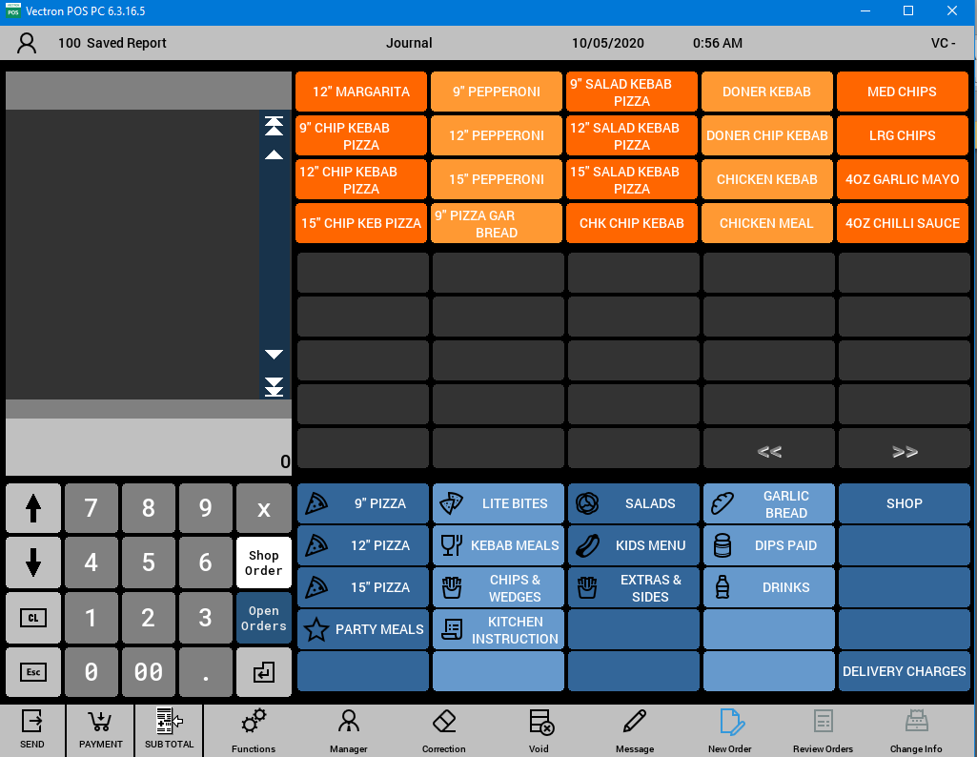

## Appendix 2

You can see that every time I had a logging point in my code, it shows up here in the TCP Log-Viewer.



## Appendix 3

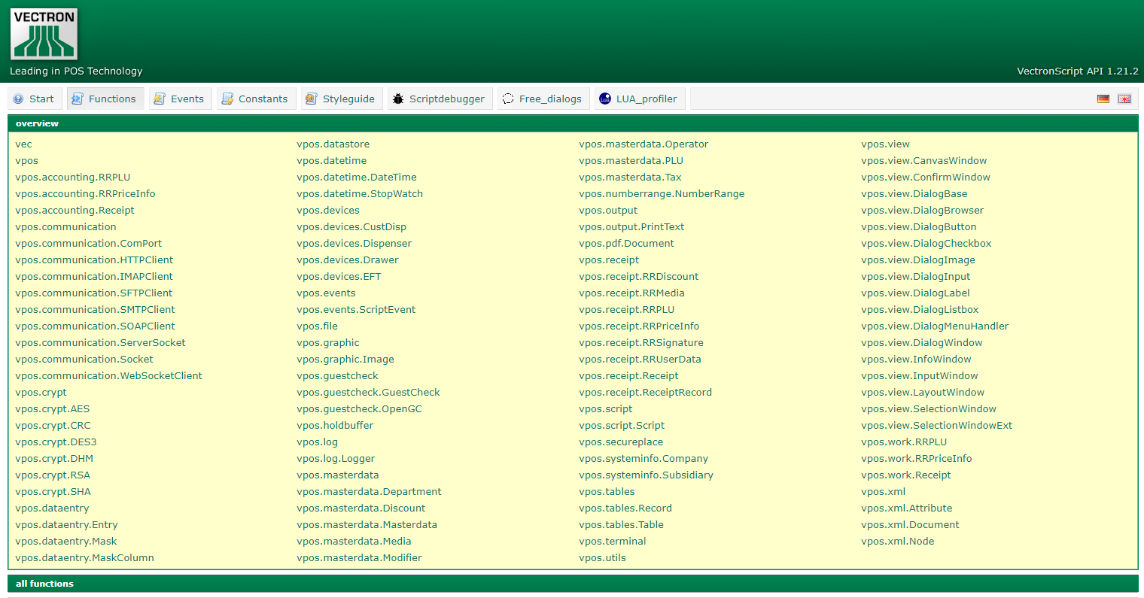Below you can see the Vectron API. The image is a list of all their current functions, each item on this list expands (when clicked) to display all lines of code with their parameters and even some examples. Giving the user every bit of accessibility needed.

## Appendix 4

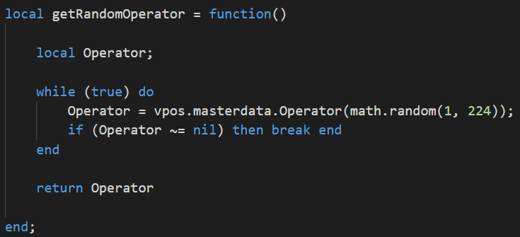

# Weekly Logs

## Week 1

**NAME:** Sean Carlin

**REPORT NO:** 1 **DATE:** 06/04/2020

Please use the space below to give details of your activities for this report period. Your outline should include - in as much detail as possible, **a breakdown of activity by project**. You should aim to address areas such as perceived organisational benefits, desired outcomes and deliverables.

For each project that you are working on – you should indicate the title, progress, targets met and expected completion date.

**Summary of activities:**

My first day on placement I was briefed into the planning and development of a bespoke software solution for a specific business requirement within the ACCS organisation. After gaining this task I felt my skills learned during my Object Orientated Programming module, like planning and designing a program, were a perfect match for this and a great opportunity for me to transcribe into the world of working in the software industry. Especially when I had the opportunity to arrange various questions regarding the requirements needed for the solution that I whom will develop, again skills of which I learned during my Business Application Development module, when I was questioning the live business for their new system.

Additionally, for this task I’ve had to gain new skills, which concluded of learning Lua and how Vectron Till Systems worked by analysing their scripts to fully understand their functionality. This included working with Titan, a Business Intelligence System that helps businesses manage their data on an easy to use platform via the cloud. From this, I gained an insight to the outcomes of what a developer would produce at the end of a project. Practically experiencing how the services like Titan and the Vectron systems turn out and function gave me a confident approach into the development of the software solution I am going to provide for ACCS Ltd.

Within my first week I personally feel I have reached *Stage 2*, which is the ‘***Interested’*** Stage of the ***Self-Directed Learning Model*** that describes ***“Goal-Setting and learning strategies”,*** as I start my time into the development of a solution that will be used within a **live business.** More stages will be reached throughout my placement duration.

**Comments on progress:**

I’ve Gained extensive knowledge with a new programming language, Lua, which reveals to be very simple to learn and implement within software solutions, Vectron Tills for example. I then learned how to plan and develop an efficient software proposal towards a ‘Client’ if I were to be running a software company. From this I personally feel I have gained a lot of new skills especially when I got to work with the outcome of a program that had been developed within the software department.

**Planned tasks:**

* Continue to learn the new language, Lua.
* Gain a better insight to the solution I will develop.
* Develop an efficient Project Proposal regarding my planned solution.

## Week 2

**NAME:** Sean Carlin

**REPORT NO:** 2 **DATE:** 13/04/2020

Please use the space below to give details of your activities for this report period. Your outline should include - in as much detail as possible, **a breakdown of activity by project**. You should aim to address areas such as perceived organisational benefits, desired outcomes and deliverables.

For each project that you are working on – you should indicate the title, progress, targets met and expected completion date.

**Summary of activities:**

During the second week of placement I began to gain more advanced knowledge of the programming language Lua. Now that I have completed the training for this language, I have been able to start building the foundation of the solution I will build. With this knowledge gained I was then introduced to the overall functionality of Titan, a business intelligence system run off the cloud, from this I learned how relationships between several pieces of data can be viewed and how products would get sold. Straight after this introductory I started to dig further into the Vectron API Script to enhance my knowledge of the various methods used by the Vectron systems.

Now that I have started to develop my solution, I’ve had to gain experience with working the Vectron Commander and a Vectron till System that is simulated on my computer where I can work on the program, tweak specific items and functions to gain a better understanding, with this program I can also test my solution in the next few days during development.

During my second week I have progressed massively and have reached *Stage 4*, which is the ‘***Self-Directed’*** Stage of the ***Self-Directed Learning Model*** that describes ***“Goal-Setting and learning strategies”,*** Reasoning for reaching this stage is the fact that I have gotten a lot more involved in the overall functionality of the business and now given my own version of the software so I can work on it freely.

**Comments on progress:**

I have now finished my learning of the Lua language and have begun to read through the Vectron API and see how it is combined with the Lua language. I now have access to the Vectron Software where I can basically simulate the till system on my computer to view/make changes during my solution.

**Planned tasks:**

* Select various methods from the Vectron API Script to use in my own solution.
* Develop more time into the foundations of my software solution.
* Retrieve more notes on how the Vectron Systems work and how they can function with Timers.

## Week 3

**NAME:** Sean Carlin

**REPORT NO:** 3 **DATE:** 20/04/2020

Please use the space below to give details of your activities for this report period. Your outline should include - in as much detail as possible, **a breakdown of activity by project**. You should aim to address areas such as perceived organisational benefits, desired outcomes and deliverables.

For each project that you are working on – you should indicate the title, progress, targets met and expected completion date.

**Summary of activities:**

During this week on placement I learned some methods used in bars to reduce the amount of people who don’t purchase anything yet spend an entire night there, this is known as ‘Minimum Consumption’. I had to write out a practice script where no matter what product was bought, (with a price under the minimum spending amount) the final amount would have been the minimum rate (if it wasn’t exceeded.) You can see this script overleaf on Page 27.

Once this task was complete, I continued to work on my solution where I made a lot of progress regarding starting my solution, by disabling methods and re-enabling them to understand how the program works and how they co-operate with one another. My solution has been broken into various blocks to help handle the code and my step by step progress much easier. During the week I worked on my ‘Login’ Block, followed by Receipt, Sell & Payment blocks, it has gotten to the point where I am now testing the overall functionality by logging in random users and creating orders to ensure my method is cashing out correctly. Soon to be followed by implementing it into the Vectron System GUI (Graphical User Interface)

Personally, I feel this week I have gained a lot of progress now that I know the Lua language and can implement it myself, by next week I think most of my solution will be complete and it will only be minor fixings needed.

**Comments on progress:**

I now have a working function, which I can partially test and operate with. I did run in to an error during the week however it has been resolved by reading more of the Vectron API, this also improved my knowledge of the Lua language as it was my Lua code at fault, as well as the Vectron methods. From this my error handling has also improved.

**Planned tasks:**

* Implement My solution to be called from the GUI instead of being run off a timer.
* Test the overall functionality
* Have an external class to run my methods from – keeping the solution class much cleaner.

**Code example here**

--the current plu number for the difference between receipt and

--minimum consumption value

minConsumptionPLUNo = 980;

--minimum consumption value

minConsumptionValue = 12;

--the media on which minimum consumption should apply

--payment type basically

minConsumptionMedia = {1,2,4};

--Applying the minimum consumption PLU to the receipt

function ApplyMinConsumption (event)

    --check parameters

    if(minConsumptionPLUNo == nil or minConsumptionValue == nil or minConsumptionMedia == nil) then

        vpos.view.showWindow(sTxtParametersIncomplete);

        return;

    else

        --get current media

        local media = event:getMedia();

        if(media == nil) then

            return

        end;

        --get current media number

        local mediaNo = media:getNo();

        if(mediaNo == nil) then

        return;

    end;

    --set default value

    local mediaIsRegistered = false;

    --if media is viable for minimum consumption

    for index, value in ipairs (minConsumptionMedia) do

        if(mediaNo == value) then

            mediaIsRegistered = true;

            break;

        end;

    end;

    if(mediaIsRegistered) then

        --get the current receipt

        local receipt = vpos.accounting.Receipt ();

        if(receipt == nil) then

            return;

        end;

        --get the current receipt value

        local currentReceiptValue = receipt:getSubTotal();

        if(currentReceiptValue == nil) then

            --minimum valu ereach

            return;

        end;

        --check if the minimum consumption has been reached.

        if(currentReceiptValue < minConsumptionValue) then

            --book a plu

            receipt:addPLU {plu = minConsumptionPLUNo, price = minConsumptionValue - currentReceiptValue}

        end;    end; end; end;

## Week 4

**NAME:** Sean Carlin

**REPORT NO:** 4 **DATE:** 27/03/2020

Please use the space below to give details of your activities for this report period. Your outline should include - in as much detail as possible, **a breakdown of activity by project**. You should aim to address areas such as perceived organisational benefits, desired outcomes and deliverables.

For each project that you are working on – you should indicate the title, progress, targets met and expected completion date.

**Summary of activities:**

A lot of progress was gained this week within the Lua language merged with Vectron API. This week I familiarised myself by calling methods I created from a separate class to my solution, also known as ***‘Scoping’***, which is one of the key techniques I learned in my visual programming module from my course. This is required for your code to work efficiently without any *‘nil errors’* when calling methods. This class with all my methods can also be called/Imported and used simultaneously without having to re-write any of that code. This is called ***‘Encapsulation’*** which I also learned within my course and now using it within the workplace (You can see this noted code Page 29 & 30). Another key skill learned this week was creating a new script and adding it to the Vectron Till Systems *Script Directory*, this gave me a proper insight on how the Vectron scripts function and how the interact with the user. At first I did struggle with this task, however, *“* [*Practice makes perfect. After a long time of practicing, our work will become natural, skill full, swift, and steady.*](https://www.azquotes.com/quote/924555?ref=practice-makes-perfect)*”[Bruce Lee 2017].*

**Comments on progress:**

This week I did struggle when creating a separate class to call functions from, due to still learning the Lua language of course. However, after some research and assistance from my mentor I managed to get it working and tested. It is now ready for use, meaning I can add a lot more methods required to get my solution up to speed. It also saves my script a lot of memory due to the reduced amount of code. In conclusion there are still some errors that need resolved.

**Planned tasks:**

* Make sale times random
* Resolve ‘Media’ not working correctly.
* Research PLU Links
* Research clocking in & clocking out functions.

-- !ScriptAPI: 1.0

--

-- Copyright (c)2020 Accs Ltd

-- Script name: Mobo2GoAPI_DemoMethods.Lua

-- Authors: Sean Carlin & Theo Huenestine

-- Date: 03/2020

-- Function: Demonstration Data Methods.

local i = 1

  local getRandomOperator = function()

    local tempOperator = true;

    local OperatorNo;

    while tempOperator == true do

        local randomOperator = math.random(1,224);

         OperatorNo = vpos.masterdata.Operator(randomOperator);

        if(OperatorNo ~= nil) then

          tempOperator = false;

        end

    end

    return OperatorNo;

 end

  local getRandomPLU = function()

 --get random plu, existing plu, sends back to calling method asking for it.

 encapsulate plu and unitprice into an object thats returned from random plu.

    local tempPLU = true;

    local PLUNo;

    while tempPLU == true do

        local randomPLU = math.random(7000,12265);

         PLUNo = vpos.masterdata.searchPLU(randomPLU);

          if(PLUNo ~= nil) then

           tempPLU = false;

          end

    end

    return PLUNo;

  end

  local getRandomQTY = function()

    local QTY = math.random(1,6);

    return QTY;

  end

  local getRandomTime = function()

    local Time = math.random(1000,10000);

    return Time;

  end

  local getRandomMedia = function()

    local tempMedia = true;

    local mediaNo;

    while tempMedia == true do

        local randomMedia = math.random(1,12);

         mediaNo = vpos.masterdata.Media(randomMedia);

        if(mediaNo ~= nil) then

          tempMedia = false;

        end

    end

    return mediaNo;

  end

 return {

 getRandomOperator = getRandomOperator,

 getRandomPLU = getRandomPLU,

 getRandomQTY = getRandomQTY,

 getRandomTime = getRandomTime,

 getRandomMedia = getRandomMedia

 };

## Week 5

**NAME:** Sean Carlin

**REPORT NO:** 5 **DATE:** 03/04/2020

Please use the space below to give details of your activities for this report period. Your outline should include - in as much detail as possible, **a breakdown of activity by project**. You should aim to address areas such as perceived organisational benefits, desired outcomes and deliverables.

For each project that you are working on – you should indicate the title, progress, targets met and expected completion date.

**Summary of activities:**

Not a lot of progress this week as my only task was to research the ‘PLU Links’ for the products within the Vectron systems, PLU links are basically options that are attached to specific products, for example, the user selects a Steak, and then the PLU link would give the user another option for how they want the steak done, e.g. well done and so on. As you can see below:

However, having the PLU links enabled caused issues with my solution as it stopped it being entered automatically since it needed a further option selected. I had some trouble trying to fix this as I couldn’t find the fault through my code. I had to diagnose the fault by commenting out lines of code individually to see what worked and what didn’t. Eventually I fixed this by disabling it, I disabled this by adding an extra piece of code to a method. After this the solution runs fine.

After some error handling I worked on the *complexity* of my program, this means I altered and cut down some unneeded code that I then *‘encapsulated’* into methods that can be written once but used many times.

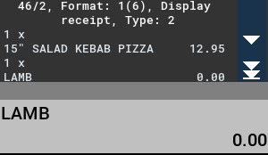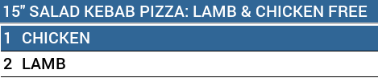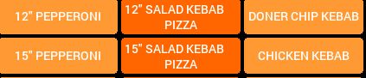

**Comments on progress:**

This week I had minimal progress due to having an issue by disabling the ‘PLU Links’ as mentioned above. However, after a short call with my mentor, Theo Huenestein, I recognised the issue, and had it resolved.

**Planned tasks:**

* Need to encapsulate more methods
* Improve complexity

## Week 6

**NAME:** Sean Carlin

**REPORT NO:** 6 **DATE:** 10/04/2020

Please use the space below to give details of your activities for this report period. Your outline should include - in as much detail as possible, **a breakdown of activity by project**. You should aim to address areas such as perceived organisational benefits, desired outcomes and deliverables.

For each project that you are working on – you should indicate the title, progress, targets met and expected completion date.

**Summary of activities:**

At the beginning of this week I encountered the following error;



Which I resolved by simply going into the Vectron API and retrieving code from the ‘Masterdata’ Class and using the following method called **masterdata.EditPLU,** once this code is used, it turns the system into *edit mode.* I used similar testing methods I was taught during my object orientated programming module to diagnose this fault, and that was by using the ‘*debugger´,* this takes you through every line of your code step-by-step and eventually I found out the issue.

Progression throughout the week resulted in implemented a timer to control the overall solution and gives it a random time to trigger each ‘run’ of the script. This gives the solution a complete random effect leaving all the data generated completely random as it is started randomly also. During this task I had issues with loops not running properly and the timer not even starting, so I used the *debugger* method again and step by step I diagnosed the fault, as “*Each step you take reveals a new horizon”[* Dan Poynter (2017)].

**Comments on progress:**

A lot of progression was made this week and the basic skeleton for my solution is here. This week I used how to implement timers efficiently so the program can run smoothly once the timer Is triggered, payment methods now also work automatically and randomly. I feel this week I gained a lot more experience in the error handling area.

**Planned tasks:**

* Start to research ‘Touchcodes’
* Look into LogViewer functions
* Research more API for efficient methods.

## Week 7

**NAME:** Sean Carlin

**REPORT NO:**7 **DATE:**17/04/2020

Please use the space below to give details of your activities for this report period. Your outline should include - in as much detail as possible, **a breakdown of activity by project**. You should aim to address areas such as perceived organisational benefits, desired outcomes and deliverables.

For each project that you are working on – you should indicate the title, progress, targets met and expected completion date.

**Summary of activities:**

This week was merely focused on the *‘Touchcode’* functionality. The touch code is a unique code for users when logging in to Vectron tills, these unique codes are linked to a magnetic key fob (Figure 1). After some research through the Vectron API I implemented the touch code function into my script. Once this was implemented, it didn’t work properly as there two ways to sign a user into the Vectron till, that is by user code, or connecting the magnetic key fob. After some error handling and testing by using loops and if statements I came up with the final solution, as you can see in page 34. I implemented multiple IF statements that make sure the user being logged in is completely valid, because *“At the end of the day, the goals are simple: safety and security” [ Jodi Rell (2016)].* If the user being randomly logged in is *invalid,* the loop will skip the ‘*Login Stage´* of this program and find a new user.

For efficiency and more randomised data, I created another if statement that selects a *login method* as well, giving the demonstration data created completely random users that were logged in differently.

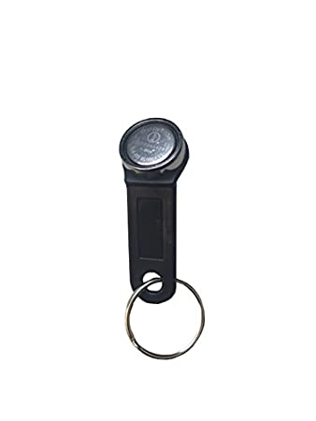

**Figure 1**

**Comments on progress:**

When I got the touch code to work efficiently, it was a major step in the skeleton of my solution. When demonstrating, no one must do anything to log a user in anymore, especially with the touch code option now implemented. I personally feel I have achieved a lot more regarding my knowledge of not only the Lua language, but with Vectron API with some of its advanced functions.

**Planned tasks:**

* A form of *‘Logging’* must now be implemented to replace the message box technique of showing the user where the program is currently at, in terms of progression. E.g. Logging in section, receipt section and so forth.
* Start to work on the Demonstration Data Tutorial document for users who will receive this solution.

-- signs in an operator via ID

                xOperator = DemoDataGeneratorLibrary.getRandomOperator()

                if (xOperator:getTouchCode() == "00000000000000") then

                    if (xOperator:getName() == "UNUSED") then end

                elseif (xOperator ~= nil) then

                    local randomSignIn = math.random(1,2);

                    if (randomSignIn == 1) then

                     vpos.holdbuffer.signInOperator(xOperator:getNo())

                    elseif (randomSignIn == 2) then

                   vpos.holdbuffer.signInOperatorByTouch(xOperator:getTouchCode());

                    end

                    logit("3. Successful Login.");

                    break

                else

                    logit("3. Unsuccessful Login. Retrying...");

                end

## Week 8

**NAME:** Sean Carlin

**REPORT NO:** 8 **DATE:** 24/04/2020

Please use the space below to give details of your activities for this report period. Your outline should include - in as much detail as possible, **a breakdown of activity by project**. You should aim to address areas such as perceived organisational benefits, desired outcomes and deliverables.

For each project that you are working on – you should indicate the title, progress, targets met and expected completion date.

**Summary of activities:**

Using my solution these past couple of weeks have been a challenge since I don’t exactly know where my program has reached in a matter of blocks, for example login block, or payment block. Luckily Vectron have their own software to enable this feature called *TCP Logviewer.* However, for this program to connect to my computer, I must create a method that enables a *‘socket´* which is a key communication method for computers with different programs. You can see in Figure 1 overleaf that the connection variable called a ‘logsocket’ is what creates the connection to my computer via Vectron’s API function called *‘vpos.communication.Socket’.*

How does my solution know how to log you may ask? The logit function in figure one sends the data straight to TCP Logviewer. In figure 2 you can see an example of the logit code being used whilst logging near the end of the script. Once my solution successfully runs and logs everything correctly, it will look like this;

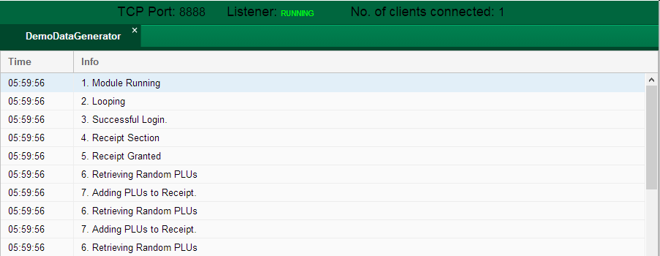

**Comments on progress:**

This week was a huge step in progression, my solution is nearing completion. Getting to use a separate software to log my program came in very handy, it also expanded my knowledge with doing the basics for created software solutions. Another key technique I learned this week was the use of Sockets, something I never heard of before even during my software development course.

**Planned tasks:**

* Go through the logging and ensure everything is logged.
* Make sure everything is clean and tidy.
* Start to tie up loose ends within my solution.



**Figure 1**

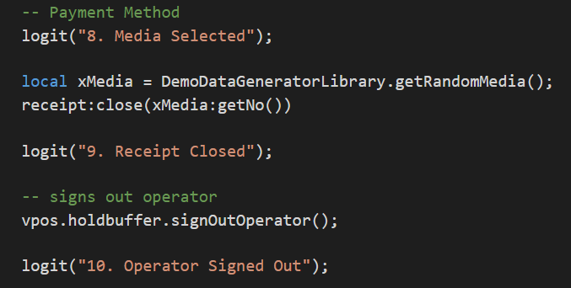

**Figure 2**

## Week 9

**NAME:** Sean Carlin

**REPORT NO:** 9 **DATE:** 1/05/2020

Please use the space below to give details of your activities for this report period. Your outline should include - in as much detail as possible, **a breakdown of activity by project**. You should aim to address areas such as perceived organisational benefits, desired outcomes and deliverables.

For each project that you are working on – you should indicate the title, progress, targets met and expected completion date.

**Summary of activities:**

As my solution was near enough complete, it was time to tie up the loose ends. This week was mainly based on testing my final solution, ensuring everything is logged correctly and all code used isn’t repetitive. When testing, I used various methods that I learned during my object orientated programming module from my course. From typing one simple character (operator code in this case) to not entering anything at all. Even if the user tries to do anything without logging in, they will get the following error message shown in figure 1.

During my testing process I noticed the operators were not signed out even after the transactions had taken place. I resolved this by implementing the simple code shown below:



After testing was complete for my program, me and my mentor Theo Huenestein, tested further on *live Vectron tills,* within a client’s business. From this testing we received a lot of positive feedback from our clients and how they are glad that this option is now available. Another thing, personally *“Software never was perfect and won’t get perfect. But is that a license to create garbage? The missing ingredient is our reluctance to quantify quality.”,* Boris Beizer (2016). From this I was very encouraged to keep my code at a high standard.

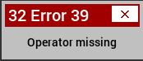

**Figure 1**

**Comments on progress:**

This week I learned a lot regarding testing techniques, I feel I’ve enhanced my knowledge learned from my object orientated programming module for future tasks to come. Now that my project is complete, all I can do is test it more, especially on live tills, and improve its efficiency and any bugs that arise if any.

**Planned tasks:**

* Get the tutorial document for users completed
* Final documents regarding the solution functionality created for ACCS.

## Week 10

**NAME:** Sean Carlin

**REPORT NO:** 10 **DATE:** 8/05/2020

Please use the space below to give details of your activities for this report period. Your outline should include - in as much detail as possible, **a breakdown of activity by project**. You should aim to address areas such as perceived organisational benefits, desired outcomes and deliverables.

For each project that you are working on – you should indicate the title, progress, targets met and expected completion date.

**Summary of activities:**

Since my solution is completed, this week I had to design and create the Tutorial document (user guide) for the clients that are getting my solution. During the process of this document I did not have any issues as I learned to create a user guide during my visual programming module. Taking this experience on board with me during my placement has really benefitted me and made things a lot easier, it has also improved my current skills! For specific parts of the tutorial document, there will be graphical imagery so it will be easier for the user when setting up this function. You can see an example of this below:

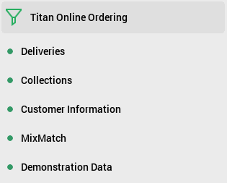

**Starting the Demonstration Data Method**

**Select ‘Functions’**

**Select ‘Demonstration Data’**

Overall actually developing a user guide for a live company that will use these for years to come is personally rewarding, at the same time it has helped me practice this skill I learned from my course, enhancing it within a live business to carry with me to future placements to come.

**Comments on progress:**

I enhanced my user guide skills and learned how to develop one to business specifics. Not much else has been learned this week as my solution is now complete and fully tested.

**Planned tasks:**

Finish up with the tutorial document and have it evaluated and checked over by my mentor.

## Weekly Log References

|  |  |
| --- | --- |
|  | TeachThought Staff (2018) *The Self-Directed Learning Model(SSDL), ,*Available at: *https://www.teachthought.com/learning/the-four-stages-of-the-self-directed-learning-model/* (Accessed: 08/03/2020). |
|  | Refer to #1. |
|  | Bruce Lee (2017) *Practice makes perfect,*Available at: *https://www.azquotes.com/quotes/topics/practice-makes-perfect.html* (Accessed: 27/03/2020). |
|  | Dan Poynter (2017) *Each step you take reveals a new horizon,*Available at: *https://www.habitsforwellbeing.com/20-quotes-to-inspire-you-to-take-small-simple-steps-each-day/* (Accessed: 27/03/2020). |
|  | Jodi Rell (2016) *At the end of the day, the goals are simple: safety and security.,*Available at: *https://www.brainyquote.com/quotes/jodi_rell_175713* (Accessed: 20/02/2020). |
|  | Boris Beizer (2016) *“Software never was perfect and won’t get perfect. But is that a license to create garbage? The missing ingredient is our reluctance to quantify quality.”,*Available at: *https://en.wikipedia.org/wiki/Boris_Beizer* (Accessed: 21/05/2020). |

# Presentation

## Slide 1

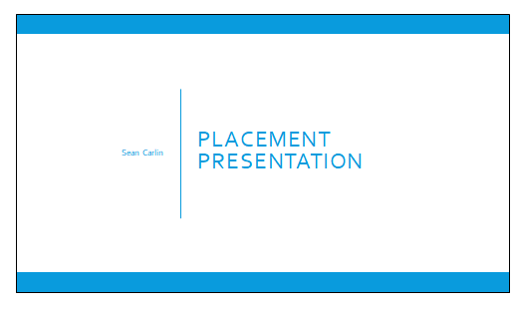

## Slide 2

## Slide 3

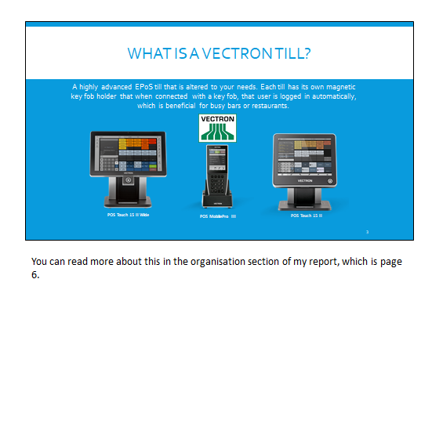

## Slide 4

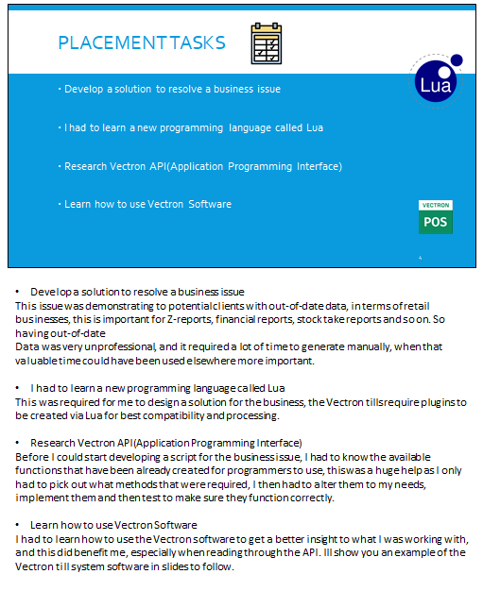



## Slide 5

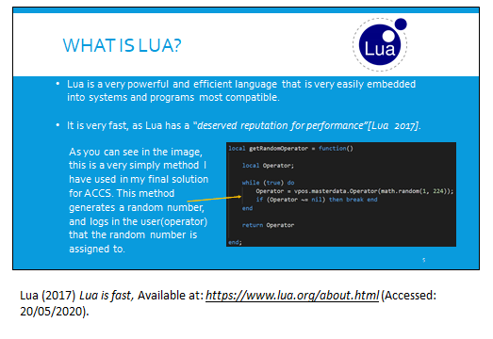

## Slide 6

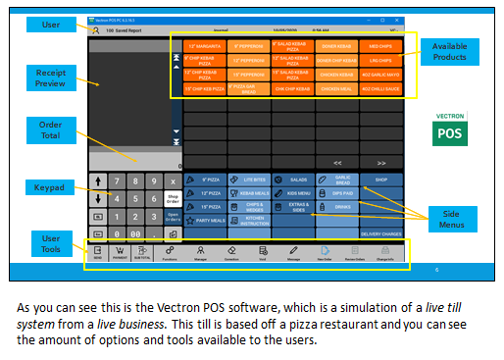

## Slide 7

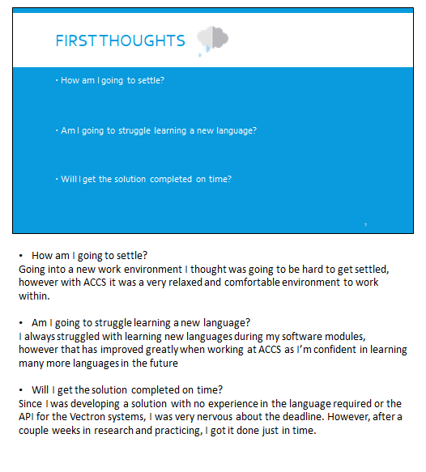

## Slide 8

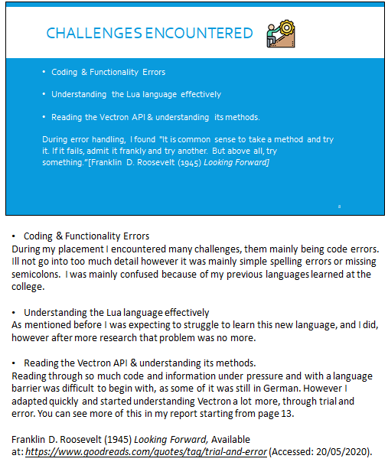

## Slide 9

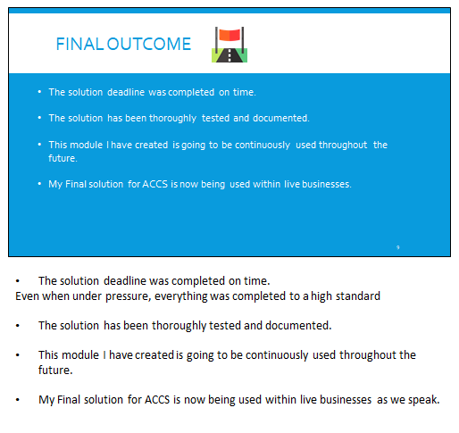

## Slide 10

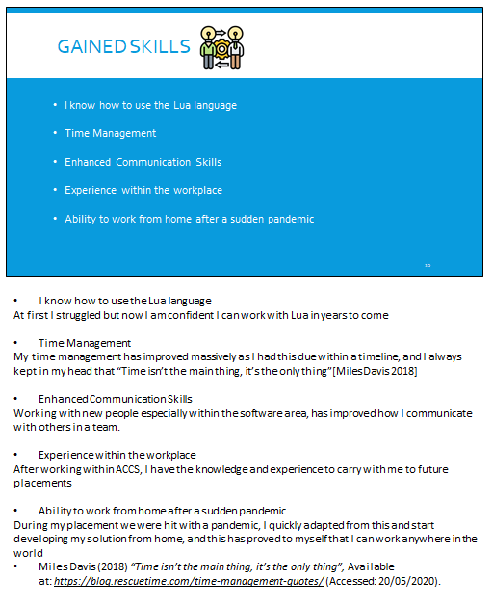

## Slide 11

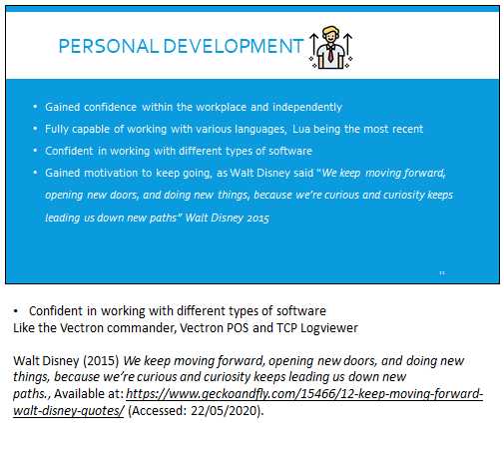

## Slide 12

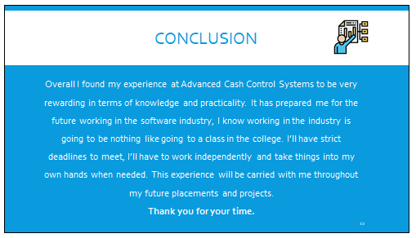

## Slide 13

## Slide 14



## Presentation References

|  |  |
| --- | --- |
|  | Lua (2017) *Lua is fast,*Available at: *https://www.lua.org/about.html* (Accessed: 20/05/2020). |
|  | Franklin D. Roosevelt (1945) *Looking Forward,*Available at: *https://www.goodreads.com/quotes/tag/trial-and-error* (Accessed: 20/05/2020). |
|  | Miles Davis (2018) *“Time isn’t the main thing, it’s the only thing”,*Available at: *https://blog.rescuetime.com/time-management-quotes/* (Accessed: 20/05/2020). |
|  | Walt Disney (2015) *We keep moving forward, opening new doors, and doing new things, because we’re curious and curiosity keeps leading us down new paths.,*Available at: *https://www.geckoandfly.com/15466/12-keep-moving-forward-walt-disney-quotes/* (Accessed: 22/05/2020). |